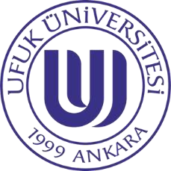 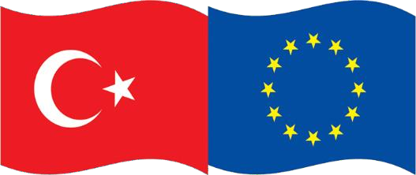 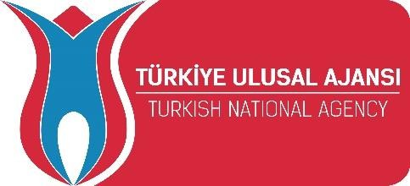 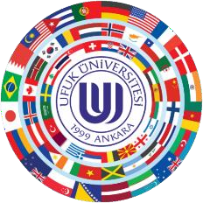

**UFUK UNIVERSITY INSTITUTIONAL INFORMATION TABLE**

|  |  |
| --- | --- |
| **Full Legal Name of**  **Institution** | **UFUK UNIVERSITY** |
| **Erasmus+ ID Code** | **TR ANKARA19** |
| **PIC Code** | **939160306** |
| **Postal Address** | **Ufuk University**  **İncek Şehit Savcı Mehmet Selim Kiraz Bulvarı**  **No: 129 (06836) İncek – Gölbaşı Ankara – TÜRKİYE** |
| **Telephone** | **+90 (312) 586 70 00 / ext. 7377** |
| **Legal Representative** | **Prof.Dr.Recai PABUÇCU** |
| **Rector (President)** | **Prof. Dr. Türkmen DERDİYOK** |
| **Official Website** | [**http://www.ufuk.edu.tr**](http://www.ufuk.edu.tr/) |
| **Erasmus Website** | [**http://erasmus.ufuk.edu.tr**](http://erasmus.ufuk.edu.tr/) |
| **E-mail** | [**erasmus@ufuk.edu.tr**](mailto:erasmus@ufuk.edu.tr) |

|  |  |
| --- | --- |
| **ERASMUS+ OFFICE** | |
| **Erasmus+ Institutional Co-Coordinator** | **Mr. Serdar ÜNVER Ph.D. Phone: +90 (312) 586 7225**  **E-mail:** [**serdar.unver@ufuk.edu.tr**](mailto:serdar.unver@ufuk.edu.tr) |
| **Webpage** | [**https://www.ufuk.edu.tr/home/kariyer-yonlendirme-ve-ua-iliskiler-birimi/erasmus**](https://www.ufuk.edu.tr/home/kariyer-yonlendirme-ve-ua-iliskiler-birimi/erasmus) |
| **Ufuk Erasmus+ Official Social Media Accounts** | [**http://www.facebook.com/ufukerasmusplus**](http://www.facebook.com/ufukerasmusplus)[**http://www.instagram.com/ufukerasmusplus**](http://www.instagram.com/ufukerasmusplus) |

|  |
| --- |
| **Academic Calendar for 2024 – 2025 Academic Year** |
| To be announced. |

|  |
| --- |
|  |
| **National Holidays** |
| 1st January New Year’s Day  23rd April National Sovereignty and Children’s Day  1st May Labor Day  19th May Youth and Sports Day  15th July Democracy and National Unity Day 30th August Victory Day  29th October Republic Day |
| **Religious Holidays\*** |
| Ramazan Bayramı (Eid) Three days holiday Kurban Bayramı (Great Eid) Four days holiday |
| *The dates of these religious holidays change according to the lunar calendar and fall on different dates each year. |

|  |  |
| --- | --- |
| **Application Deadlines for Incoming Students** | |
| **Autumn term** | **Spring term** |
| 15th July | 20th December |

|  |
| --- |
| **Information Package – Information About Academic Programmes** |
| [**http://bipa.ufuk.edu.tr**](http://bipa.ufuk.edu.tr/) |

|  |  |  |
| --- | --- | --- |
| **Departmental Coordinators** | | |
| **Faculty** | **Department** | **Responsible Person** |
| Medicine | Medicine | **Prof. Dr. Yalçın KIRICI**  E-mail: [yalcin.kirici@ufuk.edu.tr](mailto:yalcin.kirici@ufuk.edu.tr)  Phone: +90 0312 204 4294 |
| Law | Law | **Dr. Öğr. Gör. Aybüke DEMİR YEŞİLBAĞ**  E-Mail: [aybuke.demir@ufuk.edu.tr](mailto:aybuke.demir@ufuk.edu.tr)  Phone: +90 312 586 7301 |
| Education | Faculty Coordinator | **Doç. Dr. Ceyhun KARABIYIK**  E-mail: [ceyhun.karabiyik@ufuk.edu.tr](mailto:ceyhun.karabiyik@ufuk.edu.tr) Phone: +90 312 586 7475 |
| Education | English Language Teaching | **Araşt. Gör. İsa Özgür ÖZER**  E- Mail: [ozgur.ozer@ufuk.edu.tr](mailto:ozgur.ozer@ufuk.edu.tr)  Phone: +90 312 586 7470 |
| Education | Psychological Counseling & Guidance /  Educational Sciences | **Araşt. Gör. Gülce KALAYCI KARAGÜN**  E-mail: [gulce.kalayci@ufuk.edu.tr](mailto:gulce.kalayci@ufuk.edu.tr)  Phone: +90 312 586 7470 |
| Science and Literature | Psychology | **Ms. Funda KUTLU**  E-mail: [funda.kutlu@ufuk.edu.tr](mailto:funda.kutlu@ufuk.edu.tr)  Phone: +90 312 586 7413 |
| Administrative and Economics Sciences | Business | **Dr. Öğrt. Gör. Nurhan Hande SEVGİ**  E-mail: [hande.sevgi@ufuk.edu.tr](mailto:hande.sevgi@ufuk.edu.tr)  Phone: +90 312 586 7351 |
| Administrative and Economic Sciences | Management & Information Technologies | **Mr. Mesut ÜNLÜ**  E-mail: [mesut.unlu@ufuk.edu.tr](mailto:mesut.unlu@ufuk.edu.tr) Phone: +90 312 586 7366 |
| Administrative and Economic Sciences | Political Sciences and International Relations | **Dr. Öğrt. Gör. Nurhan Hande SEVGİ**  E-mail: [hande.sevgi@ufuk.edu.tr](mailto:hande.sevgi@ufuk.edu.tr)  Phone: +90 312 586 7351 |
| Administrative and Economic Sciences | International Trade | **Dr. Öğrt. Gör. Nurhan Hande SEVGİ**  E-mail: [hande.sevgi@ufuk.edu.tr](mailto:hande.sevgi@ufuk.edu.tr)  Phone: +90 312 586 7351 |
|  |  |  |

# About Ufuk University

Ufuk University is one of more than 10 private universities in capital of Turkey, Ankara. Founded in 1999, today Ufuk University has more than 6.000 students divided into 2 institutes (master’s degree), 5 faculties and 4 occupational schools and 1 continuous education center at 2 different campuses. Faculty of Medicine, Occupational School of Health Sciences, Nursing, Institute of Social Sciences and Institute of Health Sciences are located at our Balgat Campus whereas Faculties of Law, Education, Administrative and Economic Sciences, Science and Literature & Occupational Schools like Justice, Foreign Languages are located at our Incek Campus.

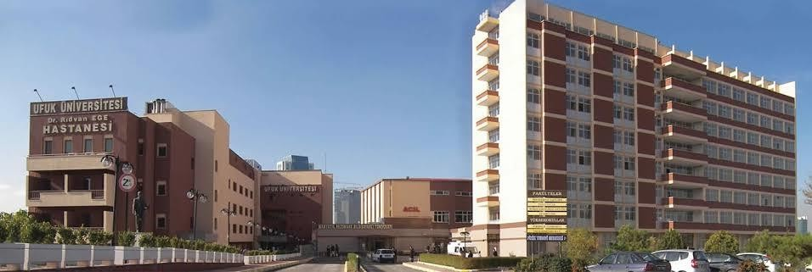

Balgat Campus is at a relatively central location. 10-minute walking distance away from couple of malls, hundreds of restaurants, shopping centers, entertainment venues, Ankara’s only inter-city bus station (AŞTI) and numerous subway stations. University’s very own medical research center (hospital) is also at this campus. This campus contains 2 canteens and 1 restaurant for use of students and staff.

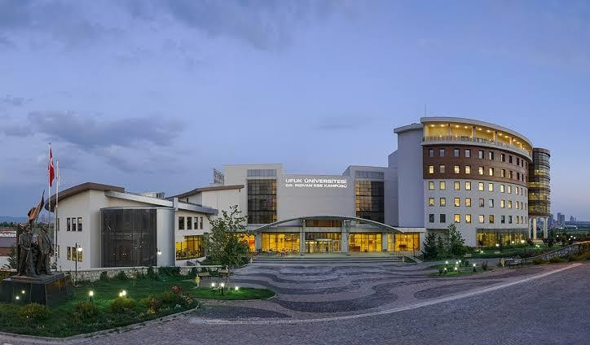

Incek Campus is 10 kilometers away from the city center, but since it’s newer (2013) than Balgat Campus, infrastructure is much more developed. University’s only dormitory (for male and female students), sports complex, semi-Olympic swimming pool, auditorium with capacity of 500, outdoor parking for all students and staff and almost all administrative offices are located at this campus as. This campus contains 1 canteen and 7 different restaurants. Transportation between two campuses is free for students and staff between 8am and 5.30pm via shuttle services.

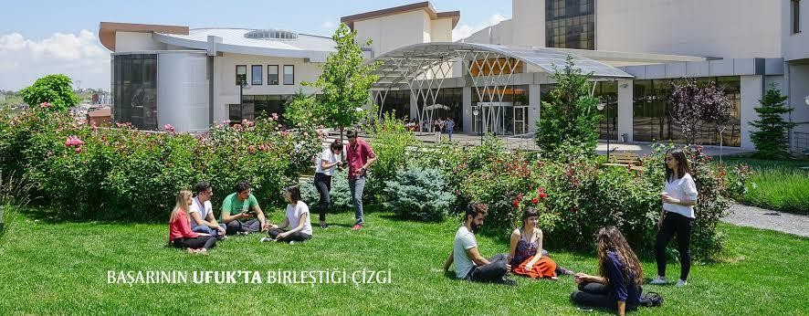

Ufuk University is a proud owner of ECHE since 2014 and actively participates in Erasmus+ projects since fall semester of 2015. Today, Ufuk University is capable of actualizing more than 30 mobilities per academic year and aims to double this by the end of 2021 project year. We have an ever-growing amount of bilateral agreements with highly prestigious universities from various countries such as France, Germany, Spain, Portugal, Poland, Romania, Bulgaria, Czech Republic etc.

As of 2022, Ufuk University continues to serve as one of the best and most contemporary higher education institutes in Ankara with more than 350 academic and 900 administrative personnel.

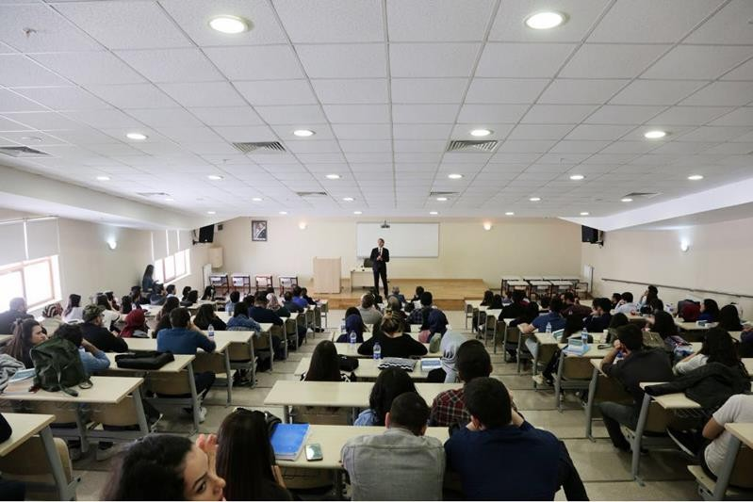

# About Turkey – Facts

**Time Zone:** GMT +3

**Capital:** Ankara

**Form of Government:** Unitary Presidential Constitutional Republic

**Total Population (2020):** 83 million

**Language:** Turkish, level of English knowledge in urban areas is reasonably high.

**Religion:** According to unofficial data, 95% of Turkey’s population is Muslim. Turkey is a secular country where people with various beliefs (or none) live and pray in harmony and peace.

**Electric Output:** Type F (plugs with 2 round tips), 250V, 16A

**Currency:** Turkish Lira (TRY). 1 EUR is equal to 16,14 TRY (as of 05.04.2022)

**Travelling to Ankara:** As capital of Turkey, many countries has direct flights to Ankara. Next best option would be a transit flight from Istanbul.

# About Ankara

It is predicted that Ankara was established nearly 3000 years ago. At first Ankara was a military garrison in Hittites period. Then, Phrygians dominated in this area and they founded the city. According to one report, the founder of the Ankara was Gordios, the king of Phrygians. According to another report, it was his son, Midas. After 700 BC, we see Lydians as the new power of the city. From 547 BC, the city and the region were under the sway of Persions.

Alexander the great gave the city to Macedonian-Helen sovereignty in 333 BC. Ankara entered the domination of Rome by Roman Commander Vulso in 189 B.C. The considerable investment for the city was made in the Romans era when Roman had hegemonised Ankara through long ages. There are a great number of masterpieces such as bathhouses, temples, city walls, councils, theatres inherited from the Roman era.

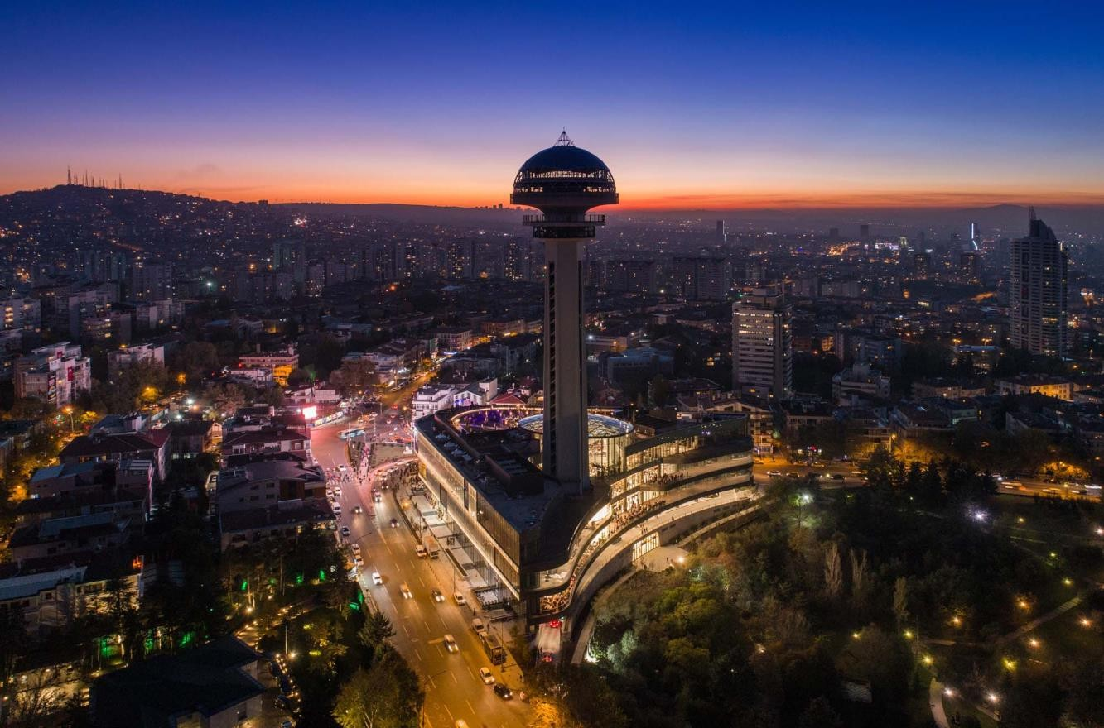

The founding-leader Mustafa Kemal Atatürk aspired that Ankara would be the capital city of the new Republic with the foundation of Modern Turkish Republic. Ankara became the capital city of Turkish Republic with the acceptance of the bill that was presented to Turkish Grand National Assembly by General Ismet and his fourteen followers on the 13th of October 1923 so that Ankara would be the capital city. Atatürk’s monumental tomb (Anıtkabir) is in Ankara as well.

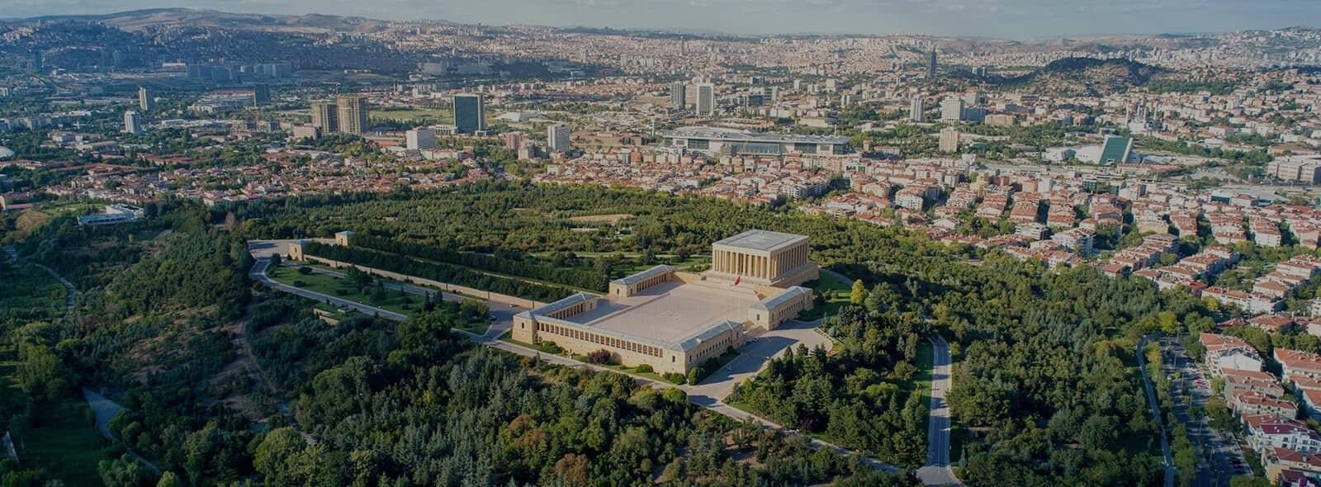

Today, Ankara is the capital of modern Republic of Turkey. With a population over 5.5 million it is Turkey’s second largest city after Istanbul. Ankara is a very old city with various Hittite, Phrygian, Hellenistic, Roman, Byzantine, and Ottoman archaeological sites. Ankara has cold, somewhat snowy winters and hot, dry summers. Rainfall occurs mostly during the spring and autumn.

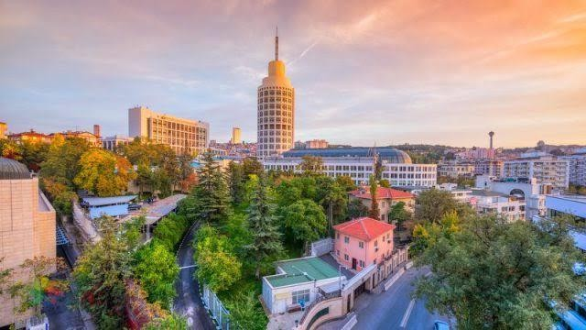

# Accommodation at Ufuk University

Ufuk University has two separate dormitories within Incek Campus. Female dormitory has 143 beds while male dormitory has a relatively lower capacity of 106. We offer free rooms to incoming internship students who complete their mobilities between June and August.

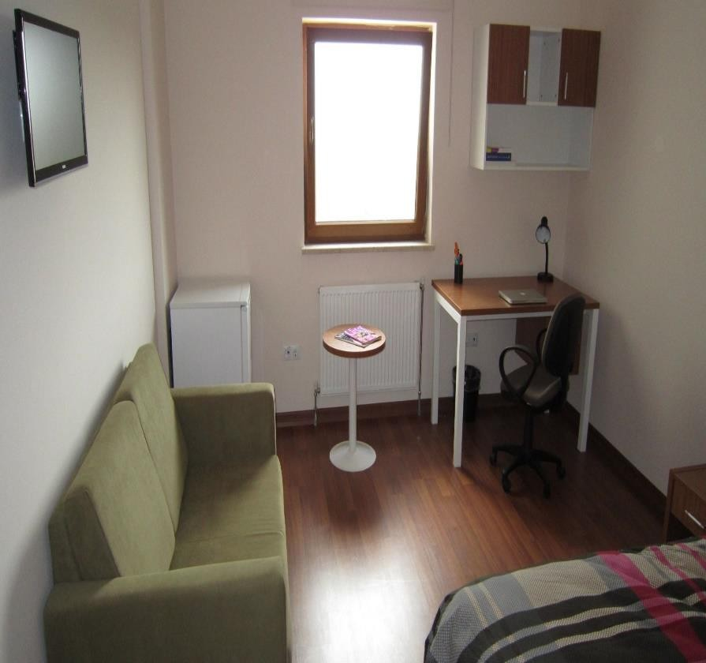Both dormitories offer:

* + Daily cleaning,
  + Free wi-fi,
  + Clean linens provided and changed every 2 weeks by room service,
  + Washing and drying machine,
  + Free of charge iron,
  + Outdoor parking,
  + 24/7 security,
  + Each room has its own separate bathroom,
  + The room is to be shared by 2 Erasmus students,

Also, if you wish to visit our institution any other time than June-August period, our Erasmus+ Office will happily aid discovering other accommodation options.

Students who wish to accommodate at Ufuk University Dormitory will be obligated to pay a pre- defined amount as caution money (deposit) upon arrival, which will be fully refunded as the student leaves.

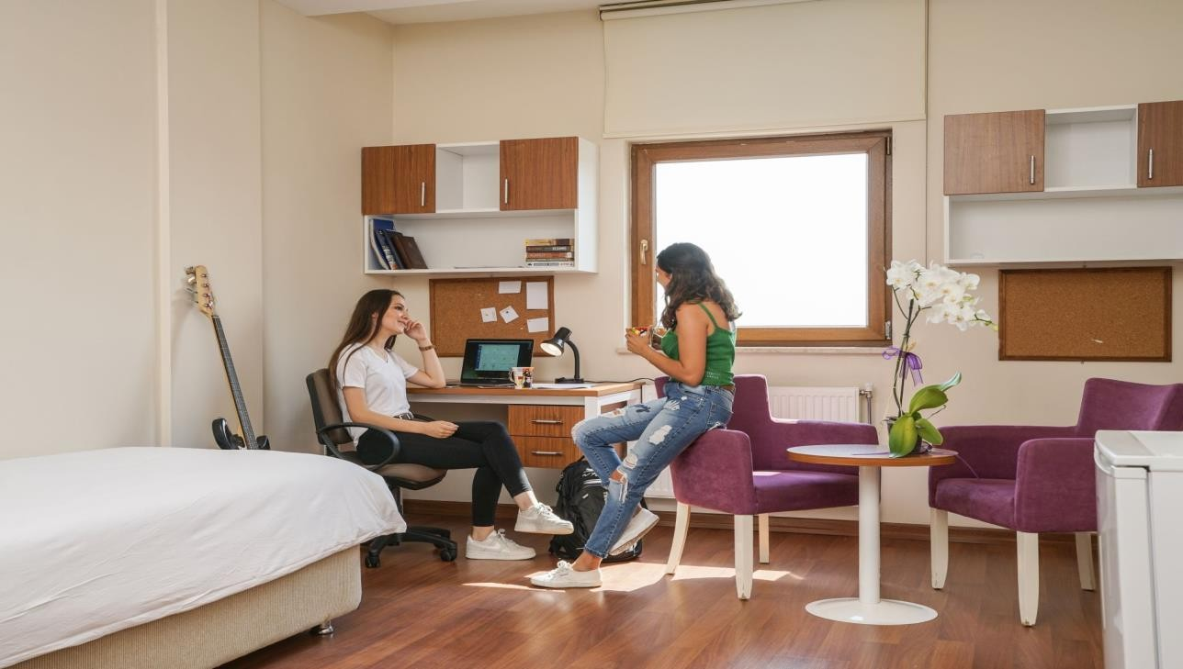

# Disabled Students Unit at Ufuk University

The aim of the Disabled Students Unit is to take the necessary measures and make arrangements in order to facilitate the education life and social participation of the disabled students studying at our university.

*Some Duties of the Disabled Student Unit:*

*To cooperate with the authorized units in order to ensure that the university campus, the buildings and open areas on the campus are accessible to students with disabilities.

*To provide time, place, materials, companion readers for the exams of students with disabilities, to take measures according to the differences arising from the nature of the disability, to contribute to the making of the necessary arrangements.

*To provide time, place, material, companion reader for the exams of students with disabilities and taking measures according to the differences arising from the nature of the disability.

# Cost of Living in Ankara

As mentioned above, as of 05.04.2022, 1 EUR = 16,14 TRY. Approximate costs for various activities and products could be listed as following:

|  |  |
| --- | --- |
| Accommodation, (single room - per month): | 200€ (approx.) |
| Transportation tickets: | 0,3€ or 0,15€ for students |
| Taxi fares: | Approximately 4,33€ for 10Km |
| Cup of coffee: | From 2€ |
| Cinema: | 2,50€ |
| Theater: | From 3€ |
| Museum: | From 4€ |
| Bread: | 1€ |
| Milk (1L): | 1€ |
| Mixed Fruits (1Kg): | 1€ |
| Fruit Juice (1L): | 1€ |
| Soda (0,3L): | 0,5€ |
| Open buffet breakfast: | From 3€ |
| Döner Kebab: | From 3€ |
| Turkish Kebab variations: | From 4€ |
| Pizza: | From 3€ |
| Fast food (with fries and drink): | From 3€ |
| Beer: | From 2€ |
| Clubs and bars: | Most clubs and bars don’t have entrance fees. |
| Mobile Phone Card (Monthly with 10GB + 1000 minutes within Turkey + 1000 SMS within Turkey) | 7€ (Cheaper and more expensive options exist) |

# Must-See Touristic Destinations

* **Anıtkabir:** Monumental tomb of M. Kemal Atatürk, founder of modern Republic of Turkey.

Open from 9am to 5pm everyday. **Entrance Fee**: Free.

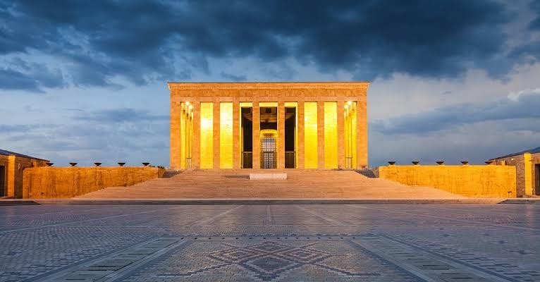

* **Museum of Anatolian Civilizations:** Contains historical masterpieces from Neolithic, Chalcolithic, Bronze Age Assyrian and Hittite eras as well as Iron Age’s Phrygian and Urartian periods. **Entrance Fee**: 45₺

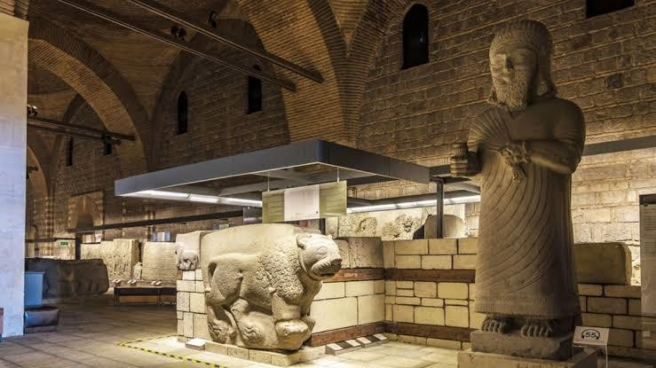

* **Eymir Lake:** Great natural place with many activities to participate in. A must-see for joggers, cyclers and kayakers. There is a bicycle path surrounding the lake with lake-side restaurants and cafes as regular stops**. Entrance Fee:** Free

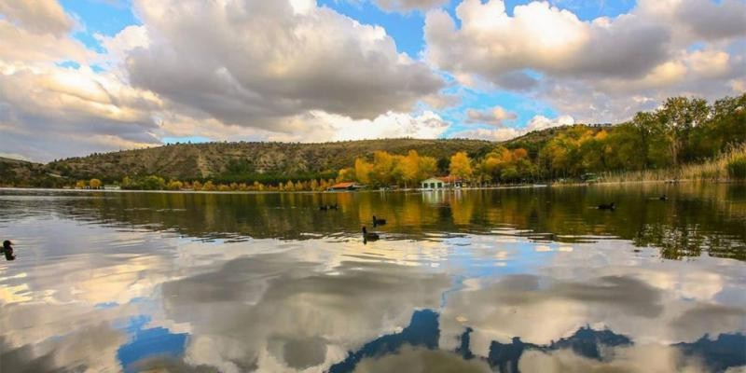

* **Ankara Castle:** Historical fortress from the late antique / early medieval era. This 1400-year- old heritage served as both a military and vital organ to many civilizations. A must-see, with an amazing panoramic view. **Entrance Fee:** Free

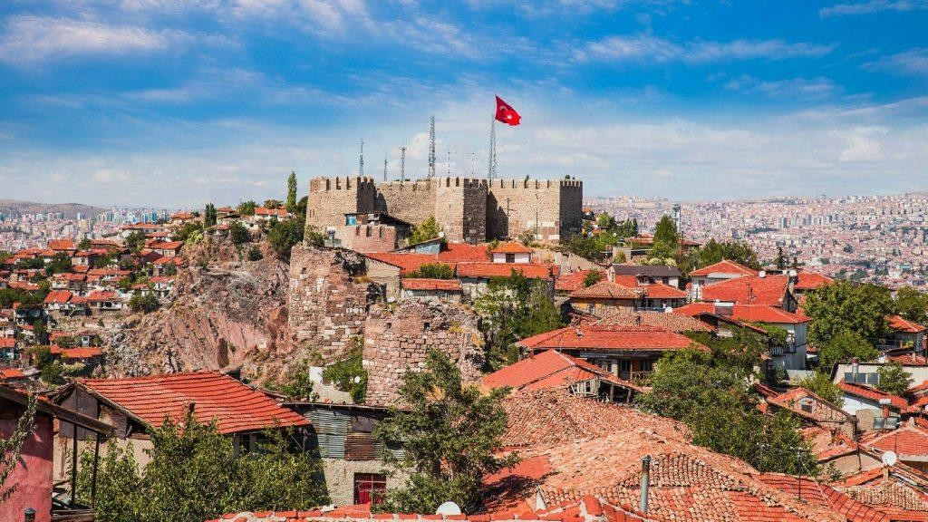

* **Ethnography Museum of Ankara:** A museum dedicated to the cultures of Turkic Civilizations extending back to 13th century. Including weaponry used by Seljuks, Mamluks ets. On the other hand, Ataturk’s sarcophagus was hosted from 1938 to 1953 within this museum before being transported to its final resting place. **Entrance Fee**: 18₺

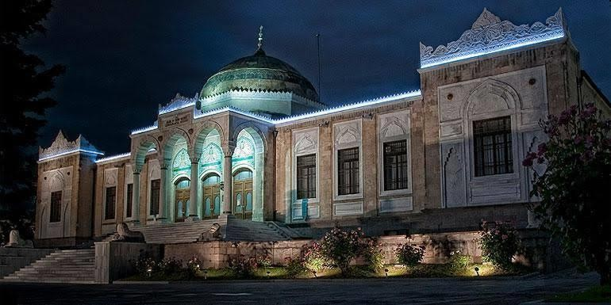

* **Aqua Vega:** Europe’s second largest tunnel aquarium, including more than 15.000 animals.

**Entrance Fee:** 45₺

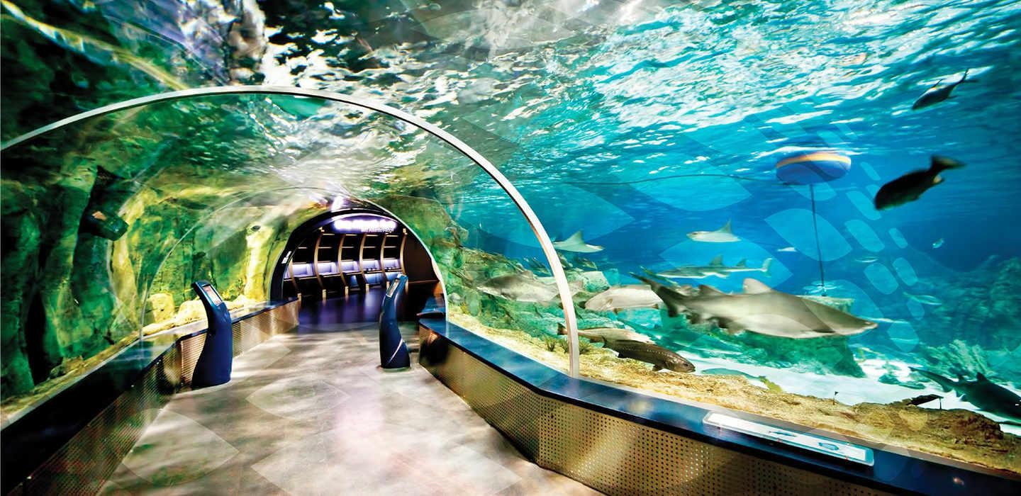

* **Atakule and Botanical Park:** Ankara’s most famous sign that should be known by any visitor. There is a newly constructed mall right beneath it with elevator access to the top of the tower. **Entrance Fee:** Free

